Which of the following is a factor of 2x2 + 4x -30 when it is completely factored?
Select one:
A. 2x – 6
B. x – 3
C. 2x + 10
D. x2 + 2x –15
Question 2
Not answered
Points out of 5.47
Flag question
Question text
The table below shows several points that satisfy a function .
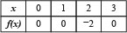
Which of the following could be the graph of this function?
Select one:
A. 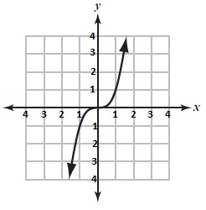
B. 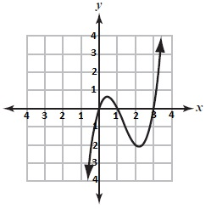
C. 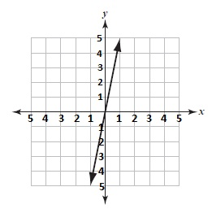
D. 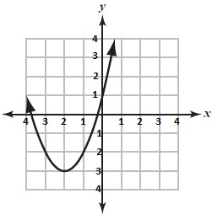
Question 3
Not answered
Points out of 5.47
Flag question
Question text
Let . Find .
Select one:
A.
B.
C.
D.
Question 4
Not answered
Points out of 5.47
Flag question
Question text
Find the slope of the line containing the points (7, -2) and (-5, 6).
Select one:
A.
B.
C.
D.
Question 5
Not answered
Points out of 5.47
Flag question
Question text
Write an equation of the line containing (2, -4) with slope 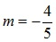
Select one:
A. 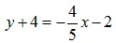
B.
C. 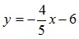
D.
Question 6
Not answered
Points out of 5.47
Flag question
Question text
Select one:
A.
B.
C.
D.
Question 7
Not answered
Points out of 5.47
Flag question
Question text
Given the functions and y(x) = , find the domain and range of y(f(x)).
Select one:
A.
B.
C.
D.
Question 8
Not answered
Points out of 5.47
Flag question
Question text
Given the function h(x) = (log(5x))3 is a composition of f(x) and g(x). Determine the functions f(x) and g(x).
Select one:
A. f(x) = log(5x), g(x) = x3
B. f(x) = 5x3, g(x) = log x
C. f(x) = x3, g(x) = log(5x)
D. f(x) = log x, g(x) = 5x3
Question 9
Not answered
Points out of 5.47
Flag question
Question text
Identify which of the following functions below is not one-to-one over the given domain.
Select one:
A. f(x) = x4 - 3x2 + 5, x < 1
B. g(x) = x + 6, x ≤ –6
C. h(x) = x2 + 4x + 2, x ≥ –2
D. j(x) = x3 +5x – 1, x > 0
Question 10
Not answered
Points out of 5.47
Flag question
Question text
Find the domain and range of the inverse function of 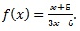
Select one:
A. 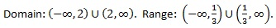
B.
C.
D.
Question 11
Not answered
Points out of 5.47
Flag question
Question text
Find the inverse function of f(x) = 5ex–5 + 5
Select one:
A. 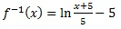
B.
C.
D.
Question 12
Not answered
Points out of 5.47
Flag question
Question text
Which of the following represents the reflection of about the x-axis?
Select one:
A. 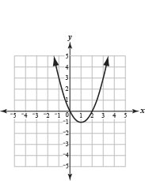
B. 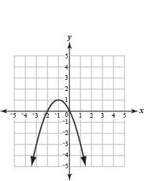
C. 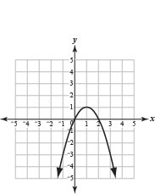
D. 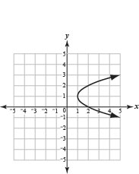
Question 13
Not answered
Points out of 5.47
Flag question
Question text
Which of the following represents the function below?
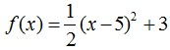
Select one:
A. 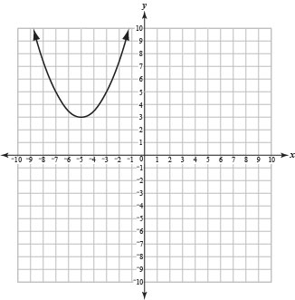
B. 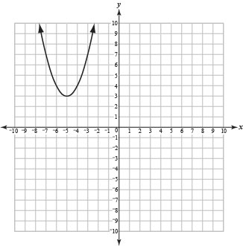
C. 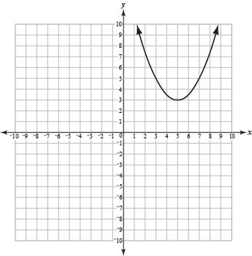
D. 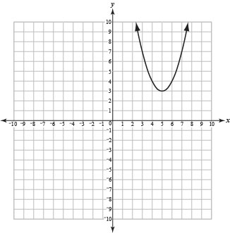
Question 14
Not answered
Points out of 5.47
Flag question
Question text
Analyze the transformations of on the parent function
Select one:
A. Reflection over the x-axis, shift right 5 units, shift down 6 units.
B. Reflection over the y-axis, shift right 5 units, shift up 6 units.
C. Reflection over the x-axis, shift left 5 units, shift down 6 units.
D. Reflection over the y-axis, shift left 5 units, shift up 6 units.
Question 15
Not answered
Points out of 5.47
Flag question
Question text
Identify the function that is neither odd nor even.
Select one:
A. f(x) = 3x4 – 8x2
B. g(x) = 4x2 – x
C. h(x) = 5x6 – 1
D. j(x) = 3x3 – 2x
Question 16
Not answered
Points out of 5.47
Flag question
Question text
Determine the end behavior of the function: .
Select one:
A. Down on the right, up on the right side
B. Down on the right, up on the left side
C. Down on the left, up on the right side
D. Down on the left, up on the left side
Question 17
Not answered
Points out of 5.47
Flag question
Question text
The polynomial of , has roots of 5 and -5. Determine the behavior of the polynomial at the root of -5 on the x-axis.
Select one:
A. Constantly decreasing
B. Constantly increasing
C. Increase to the root, then decreasing
D. Decrease to the root, then increasing
Question 18
Not answered
Points out of 5.47
Flag question
Question text
A rectangular prism has the width 2 less than the length, and the height 8 less than the length. If the volume of the box is 70 cubic units, find the approximate length, width, and height of the rectangle. Round your answer to the nearest hundredth.
Select one:
A. The length is about 9.09 units, the width is about 7.09 units, and the height is about 1.09 units.
B. The length is about 1.85 units, the width is about 3.85 units, and the height is about 11.85 units.
C. The length is about 3.01 units, the width is about 5.01 units, and the height is about 11.01 units.
D. The length is about 11.85 units, the width is about 9.85 units, and the height is about 3.85 units.
Question 19
Not answered
Points out of 5.47
Flag question
Question text
Find the restrictions of the domain and the x-intercepts of the following rational function:
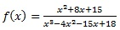
Select one:
A. Domain restrictions:
B. Domain restrictions:
C. Domain restrictions:
D. Domain restrictions:
Question 20
Not answered
Points out of 5.48
Flag question
Question text
Determine the equations of the asymptotes for the function 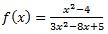
Select one:
A. 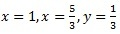
B.
C. 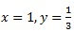
D.
Question 21
Not answered
Points out of 5.47
Flag question
Question text
What is the simplest rational function with asymptotes ?
Select one:
A. 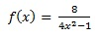
B. 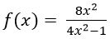
C. 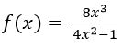
D. 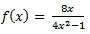
Question 22
Not answered
Points out of 4.61
Flag question
Question text
Your friend takes 6 hours more than you to paint a room, while together it takes 12 hours. How long does it take you to paint the room by yourself? Round your answer to the nearest hundredth.
Select one:
A. 13.93 hours
B. 16.94 hours
C. 18.38 hours
D. 21.37 hours
Question 23
Not answered
Points out of 5.47
Flag question
Question text
Which function is represented in the graph below?
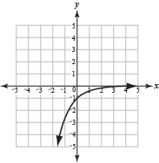
Select one:
A.
B.
C.
D.
Question 24
Not answered
Points out of 5.47
Flag question
Question text
The half-life of Plutonium-241 is about 14 years. This means that every 14 years, a sample of Plutonium decays to half of its original mass. How many years will it take for 80 grams to decay into 5 grams?
Select one:
A. 5.7
B. 16
C. 26.25
D. 56
Question 25
Not answered
Points out of 5.47
Flag question
Question text
Solve the equation 22x = 64.
Select one:
A. 32
B. 3
C. 2.5
D. log3
Question 26
Not answered
Points out of 5.47
Flag question
Question text
Simplify 1/3log 1000 +2 log 3.
Select one:
A. log60
B. log3000
C. log90
D. log1003
Question 27
Not answered
Points out of 5.47
Flag question
Question text
Calculate to 2 decimal places, log34
Select one:
A. 1
B. 1.26
C. 1.33
D. -1
Question 28
Not answered
Points out of 5.47
Flag question
Question text
Evaluate log21 – log3
Select one:
A. 7
B. log18
C. log213
D. log7
Question 29
Not answered
Points out of 5.47
Flag question
Question text
Evaluate log4 + log7
Select one:
A. log47
B. log28
C. log11
D. 28
Question 30
Not answered
Points out of 5.47
Flag question
Question text
Solve 10x =180, x correct to 2 decimal places.
Select one:
A. 17
B. 2.23
C. 2
D. 2.26
Question 31
Not answered
Points out of 5.47
Flag question
Question text
Solve ex =20
Select one:
A. 1.2
B. 3.2
C. 0
D. 3
Question 32
Not answered
Points out of 5.47
Flag question
Question text
Solve for 102x = 1,000,000
Select one:
A. 500
B. 3
C. 5,000
D. 2
Question 33
Not answered
Points out of 5.47
Flag question
Question text
Solve x in the equation 3log2x+logx2=-4
Select one:
A. x=2-1/3 or x=1/2
B. x=2-1/3
C. 1/2
D. 1
Question 34
Not answered
Points out of 5.47
Flag question
Question text
Find the value of x in logax = loga4 +4loga2
Select one:
A. log12
B. 12
C. 32
D. 64
Question 35
Not answered
Points out of 5.47
Flag question
Question text
The magnitude of an earthquake on the Richter scale is defined by the equation below,
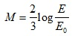
where M is the magnitude, E is the energy released by the earthquake, in joules, and is 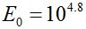, the energy released by a reference small scale earthquake.
What is the magnitude of an earthquake that releases joules of energy?
Select one:
A. -3.73
B. 3.73
C. 3.86
D. 5.56
Question 36
Not answered
Points out of 5.47
Flag question
Question text
Sound intensity is measured in decibels. The decibel (dB) is a logarithmic unit that described the ratio between two sound intensity measurements. The equation that describes the difference in decibels between two measurements is shown below.
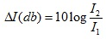
If the ratio between two measurements, , is 1000, what is the change in sound intensity, in decibels?
Select one:
A. 3
B. 30
C. 60
D. 1000
Question 37
Not answered
Points out of 5.47
Flag question
Question text
In your backyard, there is a square garden with a diagonal of 25 feet long. What are the lengths of the sides of your garden?
Select one:
A. 25 feet
B.
C.
D.
Question 38
Not answered
Points out of 5.47
Flag question
Question text
Given point on the unit circle, find the .
Select one:
A.
B. 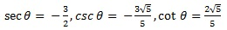
C.
D. 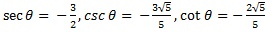
Question 39
Not answered
Points out of 5.47
Flag question
Question text
Which of the following is the graph of y = cot(x)?
Select one:
A. 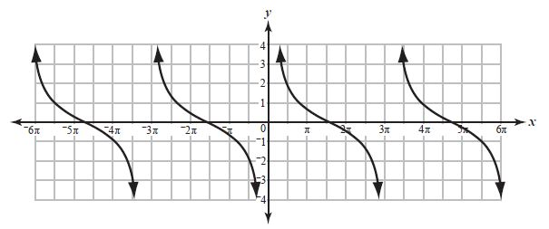
B. 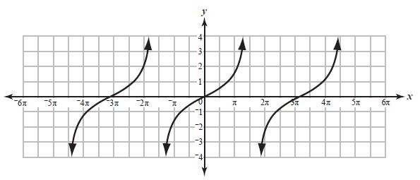
C. 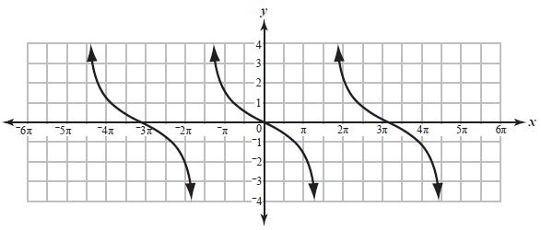
D. 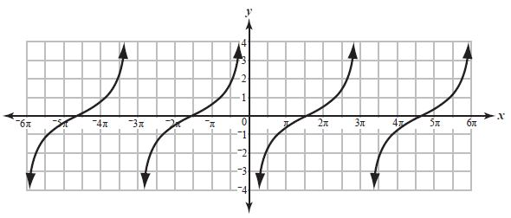
Question 40
Not answered
Points out of 5.47
Flag question
Question text
Write in terms of powers of .
Select one:
A.
B.
C.
D.
Question 41
Not answered
Points out of 5.47
Flag question
Question text
Identify the period and amplitude of 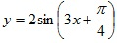.
Select one:
A. 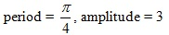
B.
C. 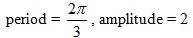
D. 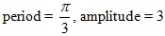
Question 42
Not answered
Points out of 5.47
Flag question
Question text
Which graph depicts ?
Select one:
A. 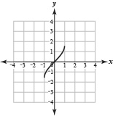
B. 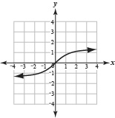
C. 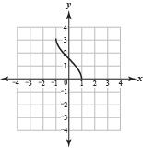
D. 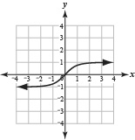
Question 43
Not answered
Points out of 5.47
Flag question
Question text
In What is the radian measure of rounded to the nearest tenth?
Select one:
A. 2.6
B. 1.8
C. 0.8
D. 0.5
Question 44
Not answered
Points out of 5.47
Flag question
Question text
Find the size of angle A. (Sides and angles are not to scale).
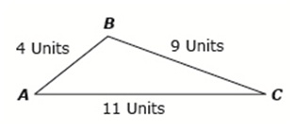
Select one:
A. 39.5 degrees
B. 42.5 degrees
C. 50.5 degrees
D. 32.5 degrees
Question 45
Not answered
Points out of 5.47
Flag question
Question text
Solve the following system by substitution.
x + y = 7
x2 + y2 = 29
Select one:
A. (x,y) = (5,2), (2,5)
B. (x,y) = (5,2)
C. (x,y) = (-5,-2)
D. (x,y) = (-5,2)
Question 46
Not answered
Points out of 5.47
Flag question
Question text
Solve the following system by substitution.
8x + 5y = 27
8x - 3y = 35
Select one:
A. (x,y) = (-4,-1)
B. (x,y) = (4,-1)
C. (x,y) = (4,1)
D. (x,y) = (-4,1)
Question 47
Not answered
Points out of 5.47
Flag question
Question text
Solve graphically x + 2y = 1 and -2x + y = -8.
Select one:
A. x =3.4 and y = 1.2
B. x = 3.4 and y = -1.2
C. x = 3.4
D. y = -1.2
Question 48
Not answered
Points out of 5.47
Flag question
Question text
Solve the inequality 4(x - 2) - 2(-x – 5) > 0
Select one:
A. x > 1/3
B. x > -1/3
C. x < 1/3
D. x < -1/3
Question 49
Not answered
Points out of 5.47
Flag question
Question text
Find the equation of a parabola with vertex at the origin and focus (-2, 0).
Select one:
A.
B.
C.
D.
Question 50
Not answered
Points out of 5.47
Flag question
Question text
An arrow is shot upwards into the air. Its height h at t seconds after it
is fired is given by . Find the time it takes the arrow to attain its maximum height.
Select one:
A. 5 seconds
B. 6 seconds
C. 9 seconds
D. 12 seconds
Question 51
Not answered
Points out of 5.47
Flag question
Question text
Find the center and radius of the circle .
Select one:
A. center (-2, 3), radius 7
B. center (-2, 3), radius 49
C. center (2, -3), radius 7
D. center (2, -3), radius 49
Question 52
Not answered
Points out of 5.47
Flag question
Question text
Find the equation of the ellipse centered at (4, -7) with a horizontal major axis of length 16 and a vertical minor axis of length 12.
Select one:
A. 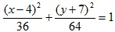
B. 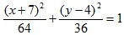
C. 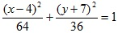
D. 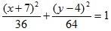
Question 53
Not answered
Points out of 5.47
Flag question
Question text
Identify the center, transverse axis, conjugate axis, and the equations of the asymptotes of the hyperbola whose equation is 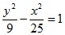.
Select one:
A. center (0, 0), transverse axis 3, conjugate axis 5, asymptotes 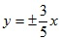
B. center (3, 5), transverse axis 6, conjugate axis 10, asymptotes 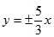
C. center (3, 5), transverse axis 3, conjugate axis 5, asymptotes 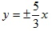
D. center (0, 0), transverse axis 6, conjugate axis 10, asymptotes 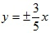
Question 54
Not answered
Points out of 5.47
Flag question
Question text
Find the perimeter and area of a semicircle of diameter 20 inches. Use 3.14 for π.
Select one:
A. p = 62.8in., a = 314in.2
B. p = 31.4in., a = 157in.2
C. p = 51.4in., a = 157in.2
D. p = 51.4in., a = 314in.2
Question 55
Not answered
Points out of 5.47
Flag question
Question text
A piece of chalk is shaped like a cylinder with a cone on top of it. The radius of both the cone and cylinder is 1 cm, the length of the cone from the center to the point is 1 cm, and the length of the cylinder is 10 cm. What is the volume of the piece of chalk?
Select one:
A.
B.
C. 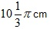
D.
Question 56

